**DBS Lab 8**

# **Sub Queries**

1. Write a query that displays employees whose job title is the same as that of employee 7369 and whose salary is greater than that of employee 7876.

Output: 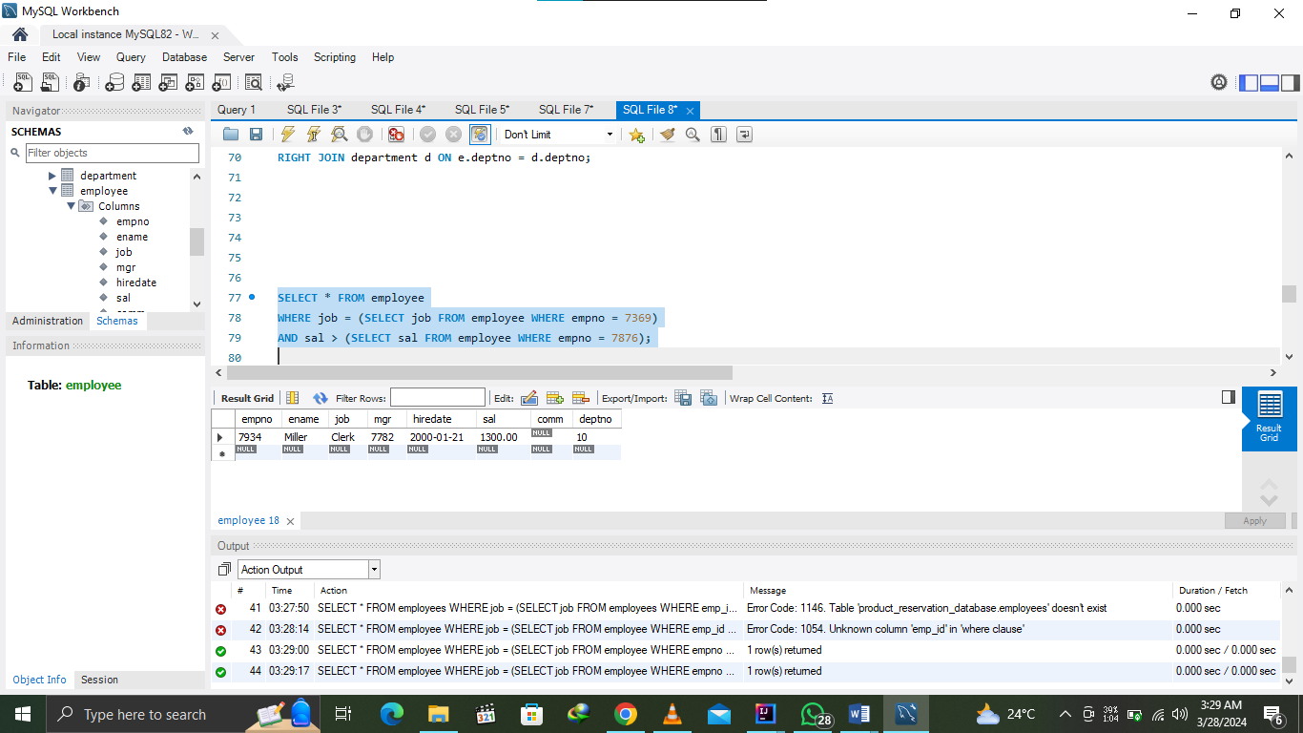

1. Find the job with the lowest average salary.

Output: 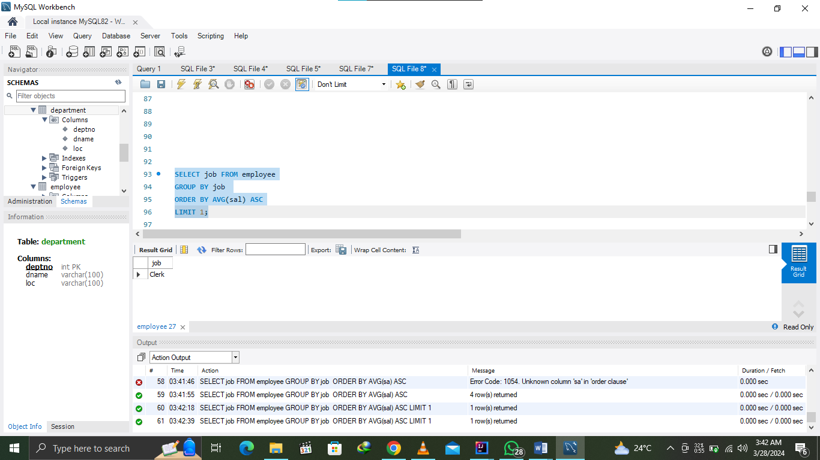

1. Write a SQL statement displays all the employees whose salary is less than any CLERK and who are not CLERK.

Output: 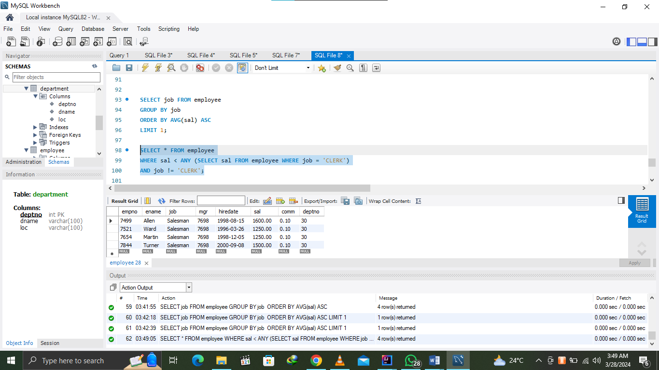

1. Find the employees who earn the same salary as the minimum salary for departments.

Output:

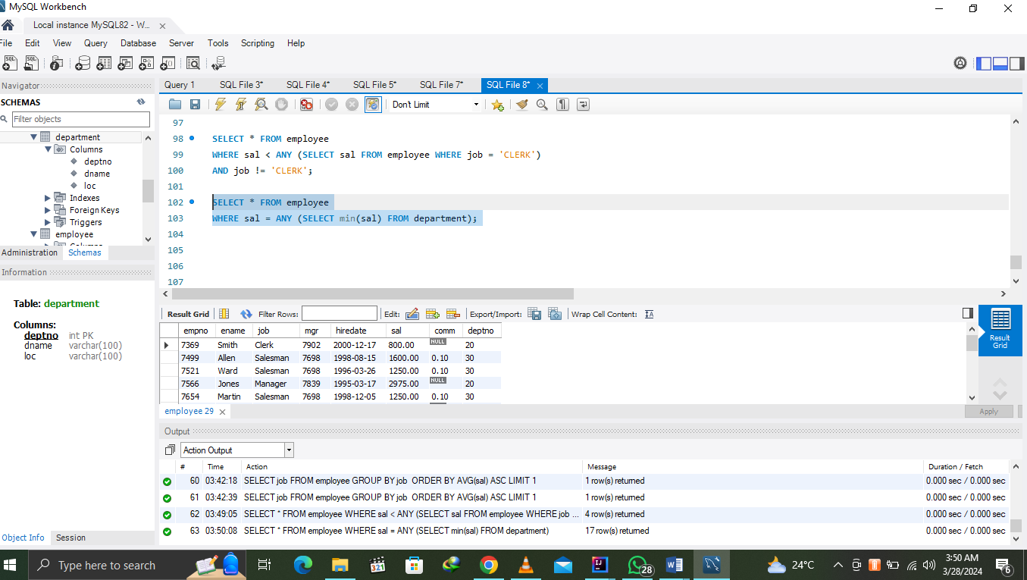

1. Write a query that displays all the departments that have a minimum salary greater than that of department 50.

Output: 